***HOSPITAL MANAGEMENT SYSTEM***

***Project: Design Pattern***

***Advisor: Miss Solat***

***Class ID: 102338(Tuesday),102337(Friday)***

***Members:***

***Mariam Khalid (8929)***

***Sakina Mariam (9247)***

***Saba Hussain(8904)***

***CREATIONAL***

***ABSTRACT FACTORY:***

To create the objects of related families i.e Ward & OPD.

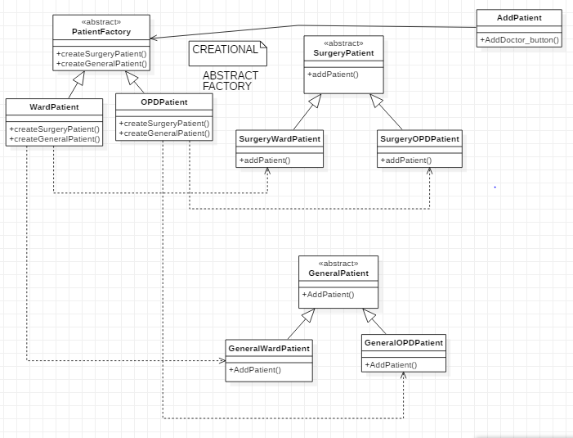

***SINGLETON:***

To create a single instance of Connection class.

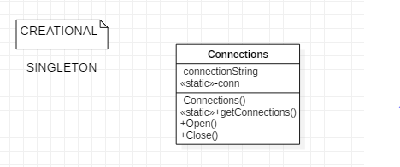

***STRUCTURAL***

***FAÇADE PATTERN:***

To provide an interface for different types of Surgery Patient.

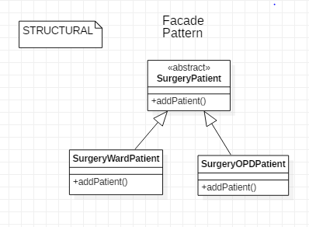

***PROXY:***

To hide Receptionist Info from all other members except admin.

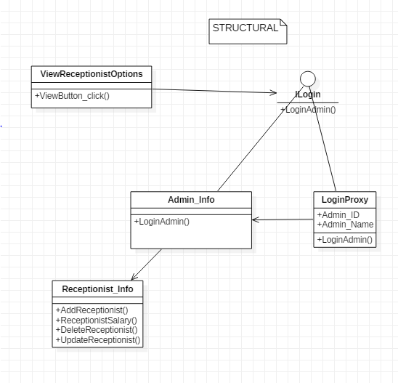

***BEHAVIORAL***

***OBSERVER***

To notify Receptionist & Doctor about his/her salary.

